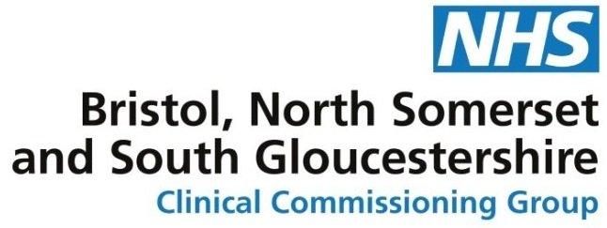
Supporting Bristol, North Somerset and South Gloucestershire CCG in Making Difficult Decisions
Bristol, North Somerset and South Gloucestershire CCG (BNSSG CCG) welcomes your interest in working with us as a member of the Exceptional Funding Panel in order to consider whether we should fund a treatment not routinely funded by the NHS locally.
We are responsible for making the best use of NHS funds allocated to meet the health needs of the local community. With demand for services greater than the money available, we must prioritise and make decisions about how we use funds carefully.
NHS cannot fund all requests for treatments for many reasons including:
- Ageing demographics
- Peer and social pressure
- New high cost drugs and experimental treatments
The CCG must consider individual circumstances when reaching decisions when requests for funding are received for treatment that is not normally funded, therefore we operate an Exceptional Funding Request Panel [EFR].
We would like to take the opportunity to involve members of the public so that our decision making is fair and robust.
The Role
This is a key role in acting as a patient voice on the Panel and your views will carry equal weight to the health professionals that sit on the EFR Panel.
We are looking for a range of people who have a keen interest in supporting the NHS in providing an effective and efficient service to patients.
This will entail attending meetings on a monthly basis (normally the first Tuesday of each month at 12.00 in South Plaza, Bristol) as well as preparing for meetings by reading applications for funding including clinical records and patient submissions.
Skills and responsibilities
- Work as a member of the EFR Panel making decisions on whether a patient is exceptional in comparison to the wider community who would also wish to access this treatment.
- Be available for:
  - Preparation for meetings by reading agenda and information sent to you
  - Participation in a monthly meeting.
(please note that the more candidates we can recruit will mean we can agree a rota for attendance rather than one person attending 12 meetings per year)
The experience, knowledge and skills we are looking for:
- The ability to be objective and to be able to separate your own experiences to the requirements of Terms of Reference of the EFR Panel.
- Experience of working on and with multi-professional groups: e.g. NHS Trust Boards, School Governors, private sector businesses, charitable, community, cultural or faith groups.
- Ability to demonstrate listening, negotiating and influencing skills, with a personal style that is challenging, but not confrontational.
- Ability to be solution focused and to act as a critical friend to the commissioners and health planners whilst promoting the patient voice in the panel
- Ability to work with others in a team and to demonstrate a commitment to non-discriminatory principles and values.
It should be noted that occasionally the nature of the requests are challenging and whilst full support and training will be given, some personal resilience will be needed.
Bristol, North Somerset and South Gloucestershire CCG will provide:
- Expenses for travel in accordance with the CCGs’ policy for reimbursement of expenses for lay involvement. You will need to check / be responsible to check if this impacts on means tested benefits you receive.
- Support to carry out this role from a named member of the team
- And anything else you feel as necessary to help you participate effectively
Timescale
- We are launching the new EFR panel from 2 April 2019.

How do you get involved?
Please use the survey link to tell us, using no more than 400 words, how you meet the role description detailed above by 25 March and we will let you know how we can involve you.
If you cannot access the survey, please tell us in no more than 400 words how you meet the criteria above by emailing: bnssg.contactus@nhs.net with the heading EFR Panel Lay member or write to Niall Mitchell, Exceptional Funding Senior Manager, Bristol, North Somerset and South Gloucestershire CCG, South Plaza, Marlborough Street, Bristol, BS1 3NX. However, in the meantime, if you have any questions, please don’t hesitate to get in touch using the email detailed above.
Promoting and supporting diversity
We value and promote diversity and are committed to equality of opportunity for all.

